**Gigabit Ethernet Fiber Switch**

**Product Description**

The Ethernet Fiber Switch has 8 1.25Gbps SC optical ports and 2 10/100/1000Mbps network ports, which can realize data communication between 1000Base-T twisted pair and 1000Base-SX/LX optical cable, and can extend the limit transmission distance of the network from 100 meters of twisted pair to 120 kilometers of optical fiber.

The installation of this fiber optic switch is simple and convenient, as it is plug-and-play without requiring any configuration. All optical and electrical interfaces comply with international standards. The product offers isolation protection, ensures good data confidentiality, operates stably, and is easy to maintain. It is suitable for various commercial and industrial environments.

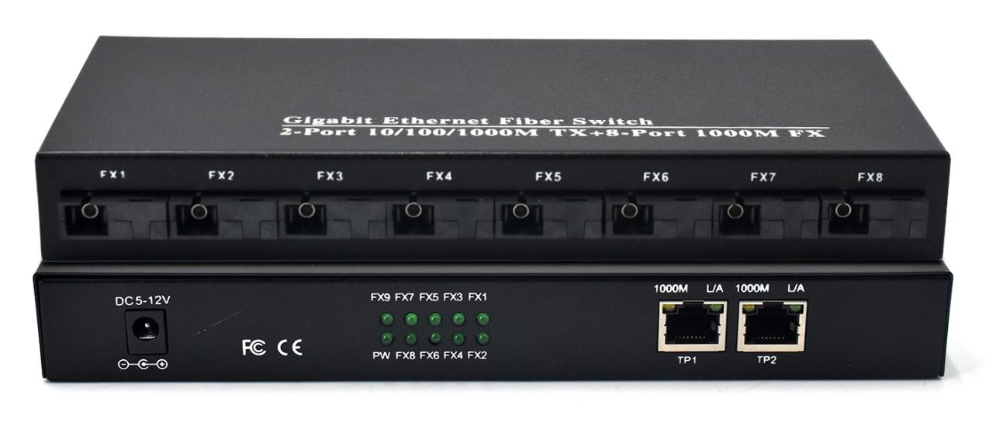

**Product Features**

* 2 10/100/1000Base-TX Ethernet ports and 8 1000Base-X fiber optic ports.
* Supports transmission of large data packets up to 10K.
* All ports support 10/100/1000Mbps rate adaptation.
* All ports support half/full duplex auto-negotiation and automatic MDI/MDI-X functionality.
* All ports support line-speed forwarding for smoother transmission.
* Plug-and-play operation, simple to use without any configuration required.
* Equipped with a metal casing for excellent heat dissipation, ensuring stable operation over long periods of time.

**Product Parameters**

|  |  |  |
| --- | --- | --- |
| Protocol | Standard | IEEE802.3 10Base-T  IEEE802.3u 100Base-TX  IEEE802.3ab 1000Base-T  IEEE802.3z 1000Base-SX/LX standards  IEEE 802.3x flow control |
| Fiber Port Characteristic | Connector Type | SC |
| Transmission rate | 1.25Gbps |
| Transmission distance | Multi-mode: 550m/2km;  Single-mode: 2/20/40/60/80/100km |
| Wavelength | Multi-mode:850nm/1310nm,  Single-mode:1310nm/1550nm/1490nm |
| Ethernet port  Characteristic | Connector Type | 1×1 RJ45 |
| Transmission rate | 10/100/1000Mbps auto-negotiate； |
| Transmission distance | 10Base-T: ≤250m（CAT3,4,5 UTP）  100Base-TX: ≤100m（CAT3,4,5 UTP）  1000Base-T: ≤100m（CAT3,4,5 UTP） |
| Exchange performance | Forward method | Store-and-forward（full wire-speed） |
| Transmission mode | Half/Full duplex adaptive |
| MAC address table | 1K |
| Case space | 1Mb |
| Jumbo frame | 9K |
| Packet Forwarding Rate | 14.88Mpps@64byte |
| Bandwidth | 20G（non-blocking） |
| LED indicator | Power supply indicator | PWR: Green |
| Fiber indicator | SC1/SC2/SC3/SC4/SC5/SC6/SC7/SC8, Green |
| Link/Act indicator | TP1/TP2, Green |
| Power parameters | Input voltage | DC5~12V |
| Power consumption | ≤6W |
| Environment | Operating Temperature | -20℃～60℃ |
| Storage Temperature: | -40℃～85℃ |
| Operating Humidity | 5%～95% non-condensing |
| Heat dissipation method | Natural heat dissipation |
| Physical properties | Size | 215×94×27mm |
| Weight | 0.5kg |

**Product Size**

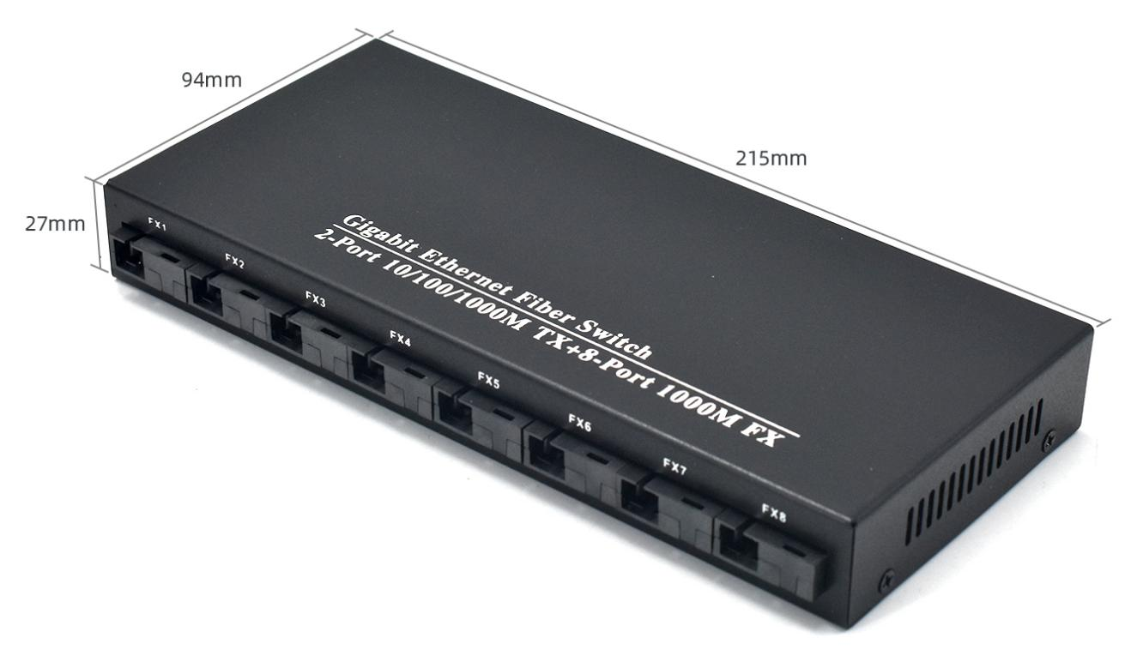

**Application**

