**NVR301-S3 Series**

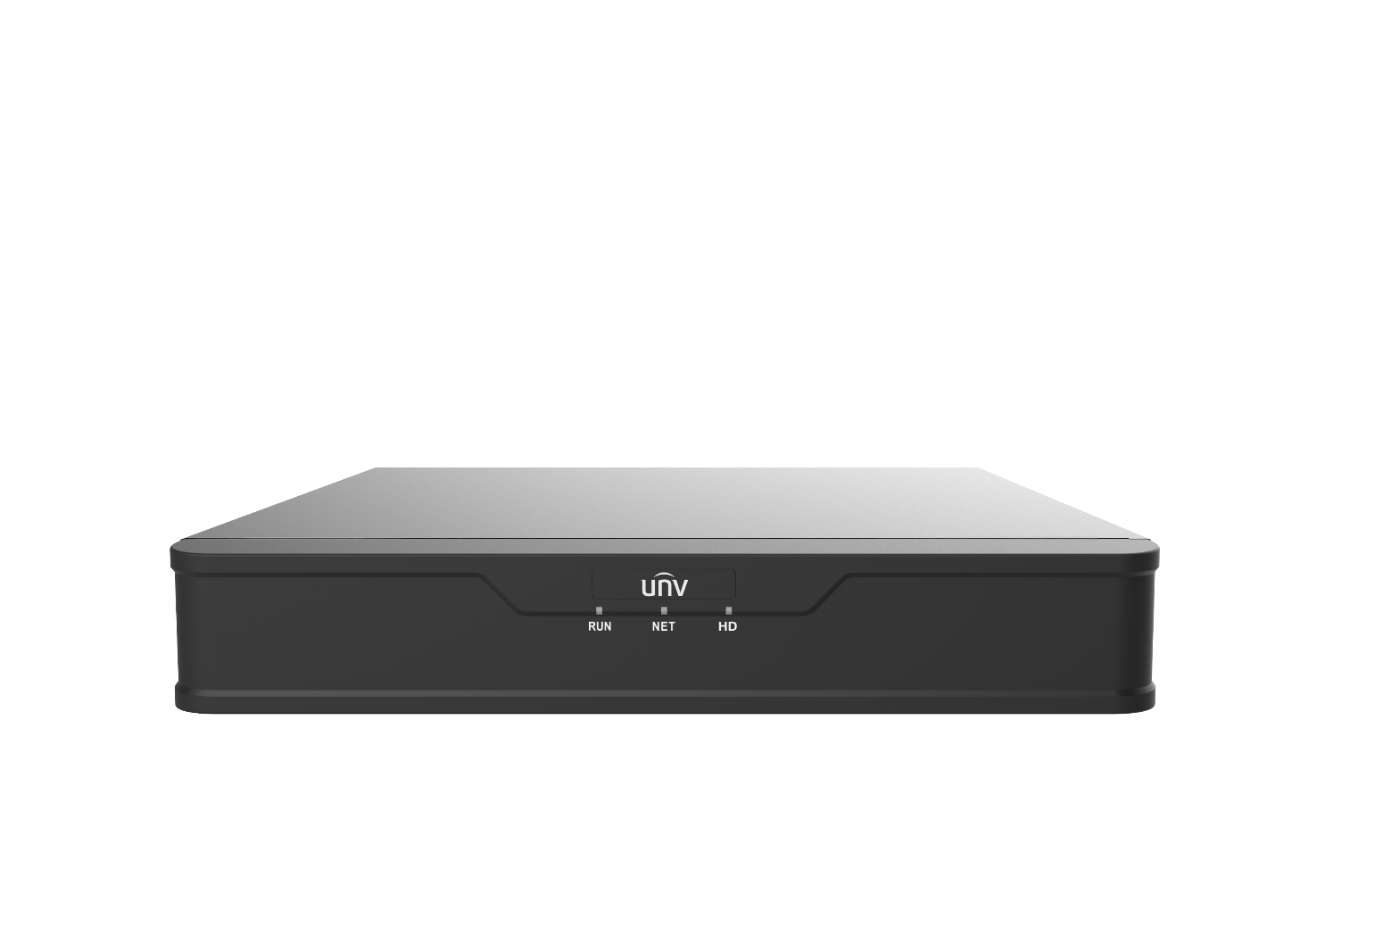

## Key Features

* Support Ultra 265/H.265/H.264 video formats
* 4/8/16-channel input
* Support mainstream cameras of ONVIF conformance(Profile S, Profile G, Profile T ) and RTSP protocols
* Support 1-ch HDMI, 1-ch VGA, HDMI at up to 4K(3840x2160) resolution
* HDMI and VGA simultaneous output
* Up to 4K resolution recording
* 1 SATA HDD up to 8TB
* Support cloud upgrade

## Specifications

|  |  |  |  |
| --- | --- | --- | --- |
| **Model** | **NVR301-04S3** | **NVR301-08S3** | **NVR301-16S3** |
| Video/Audio Input | | | |
| IP Video Input | 4-ch | 8-ch | 16-ch |
| Network | | | |
| Incoming Bandwidth | 64Mbps | | |
| Outgoing Bandwidth | 48Mbps | | |
| Remote Users | 128 | | |
| Protocols | TCP/IP, P2P, UPnP, NTP, DHCP, PPPoE, HTTP, HTTPS, DNS, DDNS, SMTP, RTSP | | |
| Video/Audio Output | | | |
| HDMI/VGA Output | HDMI:  3840x2160/30Hz, 1920x1080/60Hz, 1920x1080/50Hz, 1600x1200/60Hz, 1280x1024/60Hz, 1280x720/60Hz, 1024x768/60Hz  VGA:  1920x1080/60Hz, 1920x1080/50Hz, 1600x1200/60Hz, 1280x1024/60Hz, 1280x720/60Hz, 1024x768/60Hz | | |
| Recording Resolution | 4K/5MP/4MP/3MP/1080p/960p/720p/D1/2CIF/CIF | | |
| Audio Output | 1-ch, 3.5mm | | |
| Audio Compression | G.711A, G.711U | | |
| Synchronous Playback | 4-ch | 8-ch | 16-ch |
| Liveview display | 1/4 | 1/4/6/8/9 | 1/4/6/8/9/16 |
| Corridor Mode Screen | 3/4 | 3/4/5/7/9 | 3/4/5/7/9/10/12/16 |
| Snapshot | | | |
| FTP/Schedule/Event Snapshot | 1-ch snapshot, up to D1 resolution | | |
| Decoding | | | |
| Decoding format | Ultra 265/H.265/H.264 | | |
| Liveview/Playback | 4K/5MP/4MP/3MP/1080p/960p/720p/D1/2CIF/CIF | | |
| Capability | 1 x 4K@30, 4 x 5MP@25, 4 x 4MP@25, 4 x 3MP@25, 4 x 1080p@30 | 1 x 4K@30, 4 x 5MP@25, 4 x 4MP@25, 4 x 3MP@25, 4 x 1080p@30, 8 x 720p@30 | 1 x 4K@30, 4 x 5MP@25, 4 x 4MP@25, 4 x 3MP@25, 4 x 1080p@30, 8 x 720p@30, 16 x D1@25 |
| Hard Disk | | | |
| SATA | 1 SATA interface | | |
| Capacity | Up to 8TB for each disk  (The maximum HDD capacity varies with environment temperature) | | |
| Smart | | | |
| VCA Detection by Camera | Intrusion Detection, Cross Line Detection, Enter Area, Leave Area, Audio Detection, Ultra Motion Detection(UMD) | | |
| VCA Search | Behavior Search | | |
| Smart Intrusion Prevention (SIP) by Camera | 4-ch(Alarm only, no image) | | |
| UMD by Camera | 4-ch | | |
| General Alarm | | | |
| General Alarm | Motion, Tampering, Human Body Detection, Video Loss, Alarm Input | | |
| Alert Alarm | IP Conflict, Network Disconnected, Disk Offline , Disk Abnormal, Illegal Access, Hard Disk Space Low, Hard Disk Full, Recording/Snapshot Abnormal | | |
| External Interface | | | |
| Network Interface | 1 RJ45 10M/100M self-adaptive Ethernet Interface | | |
| USB Interface | Rear panel: 2 x USB2.0 | | |
| RS232 | NA | | |
| RS485 | NA | | |
| Alarm In | NA | | |
| Alarm Out | NA | | |
| General | | | |
| Power Supply | 12V DC  Power Consumption: ≤5 W (without HDD) | | |
| Working Environment | -10°C ~ + 55°C (+14°F ~ +131°F), Humidity ≤ 90% RH (non-condensing) | | |
| Dimensions (W×D×H) | 260mm × 240mm × 46mm (10.2"×9.4"×1.8 ") | | |
| Weight (without HDD) | ≤0.98kg (2.16 lb) | | |
| Certification | | | |
| Certification | CE, FCC, UL, RoHS, WEEE | | |
| CE | EN 55032: 2015, EN 61000-3-3: 2013, EN IEC 61000-3-2: 2019, EN 55035: 2017 | | |
| FCC | Part15 Subpart B, ANSI C63.4 | | |

## Dimensions

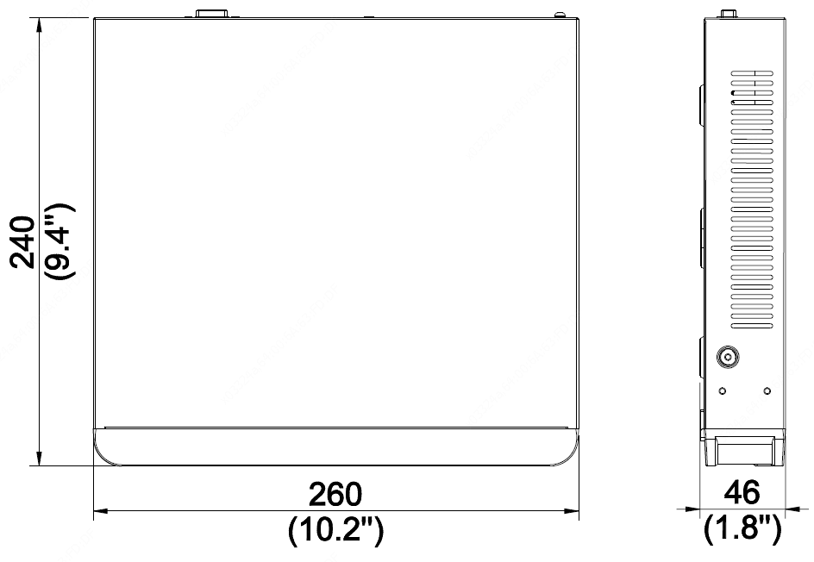

## Rear Panel



Zhejiang Uniview Technologies Co., Ltd.

Building No.10, Wanlun Science Park, Jiangling Road 88, Binjiang District, Hangzhou, Zhejiang, China

Email: [overseasbusiness@uniview.com](mailto:overseasbusiness@uniview.com); globalsupport@uniview.com

http://www.uniview.com

©2020-2022 Zhejiang Uniview Technologies Co., Ltd. All rights reserved.

* Product specifications and availability are subject to change without notice.