N09-N16-N32 SERİ

Key Features
- Support Ultra 265/H.265/H.264 video formats
- 4/8/16-channel input
- Support mainstream cameras of ONVIF conformance(Profile S, Profile G, Profile T ) and RTSP protocols
- Support 1-ch HDMI, 1-ch VGA, HDMI at up to 4K(3840x2160) resolution
- HDMI and VGA simultaneous output
- Up to 4K resolution recording
- 1 SATA HDD up to 8TB
- Support cloud upgrade

Specifications
Model | NVR301-04S3 | NVR301-08S3 | NVR301-16S3
Video/Audio Input
IP Video Input | 4-ch | 8-ch | 16-ch
Network
Incoming Bandwidth | 64Mbps
Outgoing Bandwidth | 48Mbps
Remote Users | 128
Protocols | TCP/IP, P2P, UPnP, NTP, DHCP, PPPoE, HTTP, HTTPS, DNS, DDNS, SMTP, RTSP
Video/Audio Output
HDMI/VGA Output | HDMI:  3840x2160/30Hz, 1920x1080/60Hz, 1920x1080/50Hz, 1600x1200/60Hz, 1280x1024/60Hz, 1280x720/60Hz, 1024x768/60Hz  VGA:  1920x1080/60Hz, 1920x1080/50Hz, 1600x1200/60Hz, 1280x1024/60Hz, 1280x720/60Hz, 1024x768/60Hz
Recording Resolution | 4K/5MP/4MP/3MP/1080p/960p/720p/D1/2CIF/CIF
Audio Output | 1-ch, 3.5mm
Audio Compression | G.711A, G.711U
Synchronous Playback | 4-ch | 8-ch | 16-ch
Liveview display | 1/4 | 1/4/6/8/9 | 1/4/6/8/9/16
Corridor Mode Screen | 3/4 | 3/4/5/7/9 | 3/4/5/7/9/10/12/16
Snapshot
FTP/Schedule/Event Snapshot | 1-ch snapshot, up to D1 resolution
Decoding
Decoding format | Ultra 265/H.265/H.264
Liveview/Playback | 4K/5MP/4MP/3MP/1080p/960p/720p/D1/2CIF/CIF
Capability | 1 x 4K@30, 4 x 5MP@25, 4 x 4MP@25, 4 x 3MP@25, 4 x 1080p@30 | 1 x 4K@30, 4 x 5MP@25, 4 x 4MP@25, 4 x 3MP@25, 4 x 1080p@30, 8 x 720p@30 | 1 x 4K@30, 4 x 5MP@25, 4 x 4MP@25, 4 x 3MP@25, 4 x 1080p@30, 8 x 720p@30, 16 x D1@25
Hard Disk
SATA | 1 SATA interface
Capacity | Up to 8TB for each disk  (The maximum HDD capacity varies with environment temperature)
Smart
VCA Detection by Camera | Intrusion Detection, Cross Line Detection, Enter Area, Leave Area, Audio Detection, Ultra Motion Detection(UMD)
VCA Search | Behavior Search
Smart Intrusion Prevention (SIP) by Camera | 4-ch(Alarm only, no image)
UMD by Camera | 4-ch
General Alarm
General Alarm | Motion, Tampering, Human Body Detection, Video Loss, Alarm Input
Alert Alarm | IP Conflict, Network Disconnected, Disk Offline , Disk Abnormal, Illegal Access, Hard Disk Space Low, Hard Disk Full, Recording/Snapshot Abnormal
External Interface
Network Interface | 1 RJ45 10M/100M self-adaptive Ethernet Interface
USB Interface | Rear panel: 2 x USB2.0
RS232 | NA
RS485 | NA
Alarm In | NA
Alarm Out | NA
General
Power Supply | 12V DC  Power Consumption: ≤5 W (without HDD)
Working Environment | -10°C ~ + 55°C (+14°F ~ +131°F), Humidity ≤ 90% RH (non-condensing)
Dimensions (W×D×H) | 260mm × 240mm × 46mm (10.2"×9.4"×1.8 ")
Weight (without HDD) | ≤0.98kg (2.16 lb)
Certification
Certification | CE, FCC, UL, RoHS, WEEE
CE | EN 55032: 2015, EN 61000-3-3: 2013, EN IEC 61000-3-2: 2019, EN 55035: 2017
FCC | Part15 Subpart B, ANSI C63.4

Dimensions
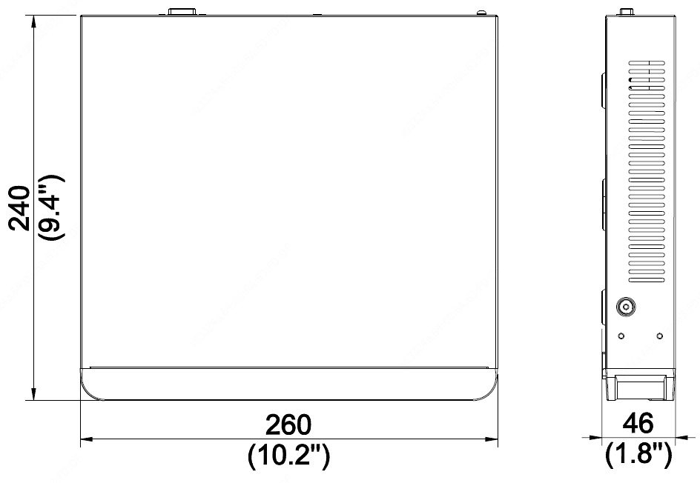

Rear Panel

